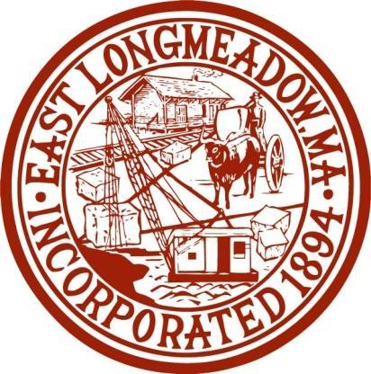
To: Commercial Business in East Longmeadow
From: East Longmeadow Health Department
RE: Mandatory Recycling Regulations

This notice is a reminder that recycling is mandatory for all businesses in East Longmeadow. The Regulation for Refuse and Recycling Collection was amended November 8, 2017, by the Board of Health requiring recycling for all business. This regulation is similar to our mandatory residential recycling program. This requirement applies to all owners, tenants, occupants, and property managers of residential, multifamily, commercial, municipal, and institutional structures and properties in the Town of East Longmeadow, Massachusetts General Laws Chapter 11, Section 31 authorizes this program.

Local businesses are not required to have their trash service company be their recycling service company, but haulers are required to offer both services. Haulers must provide the names of their trash only Commercial Customers to the Town so the Town can follow up to ensure the waste ban is being followed.

Enforcement of these regulations may be by criminal complaint in Massachusetts District
Court and/or non-criminal disposition ticket, as authorized under Massachusetts General Laws Chapter 111 Section 31. The issuance of a fine or penalty shall not preclude the Town of East Longmeadow from seeking or obtaining any or all other legal and equitable remedies to prevent or remove a violation of this section. The East Longmeadow Board of Health or their agents (including the Health Director, Inspector, any members of DPW, any police officers or the Recycling Coordinator) shall have the power to enforce the provisions of these regulations.

Penalties
Violations of these regulations shall be punished by fines and penalties as follows:
First offense: Warning
Second offense: $50.00
Third offense: $200.00
Subsequent offenses: Up to $200.00 for each subsequent offense
Each day of failure to comply with these regulations may constitute a separate violation.

Violations involving hazardous substances or Restricted Materials may result in fines up to $1,000.00 in addition to any clean-up costs described elsewhere in these regulations.

The East Longmeadow Board of Health may deny, suspend, revoke, or refuse to renew a rubbish/recycling haulers (RTDP) permit for failure to comply with any provision of these regulations.

The regulations are available online at http://www.eastlongmeadowma.gov/645/Health-Department or https://www.eastlongmeadowma.gov/757/Policies-and-Regulations You may also contact the Health Department at (413) 525-5400 x 1103 or health.department@eastlongmeadowma.gov.

Best,
Tammy Spencer, M.S.,R.S,Health Director

